

 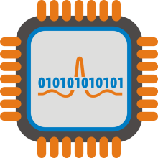   

**Neural Data Analog Front-End CPU Preprocessing Wireless Transmission Secure Server**

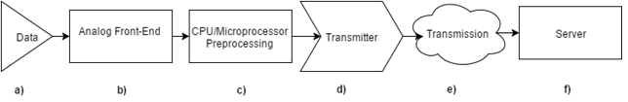

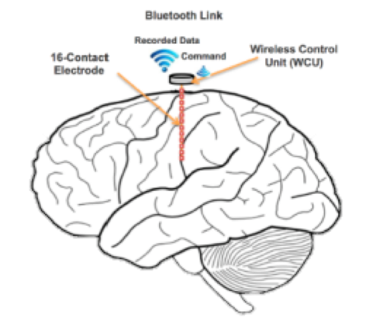

|  |  |
| --- | --- |
| Criteria | Target Value |
| Data Channels | 16 Channels |
| Data Precision | 8 Bits |
| Sampling Frequency | 1.0 kHz |
| Form Factor | 15 x 15 x 15 mm |
| Battery Life | 12 Hours |

